Asia Environmental Foundation

APRIL 2015
GREEN OFFICE GUIDE FOR SMEs
Overview of goals and implementation steps
GREEN OFFICE GUIDE FOR SMEs

1. INTRODUCTION 2
2. HOW TO INITIATE A GREEN OFFICE PROJECT 3
3. TIPS FOR GREEN OFFICE PROJECTS 4
Appendix I - List of Environmental Recognition Schemes in Hong Kong 9
Appendix II - Do's and Don'ts of Paper Recycling 10
Appendix III - Useful Links 11

INTRODUCTION

Corporate social responsibility (CSR) is about striking a balance among economic, social and environmental performances of a business operation. CSR is often linked with large and international corporations. Indeed, local small and medium enterprises (SMEs) can also engage in CSR. It does not cost a fortune! Launching a green office initiative might be the easiest way for local SMEs to get started in CSR.

Environmental protection is a key element in CSR. Apart from improving your business’ goodwill and raising corporate image, being environmentally friendly will also bring along other tangible benefits such as cost saving and improved productivity and operational efficiency, that leads to a sustainable growth.

Ultimate goal of the green office initiative is to create a greener, cleaner and more sustainable workplace by avoiding or minimising waste, collecting and recycling suitable materials and buying recycled or green office products.

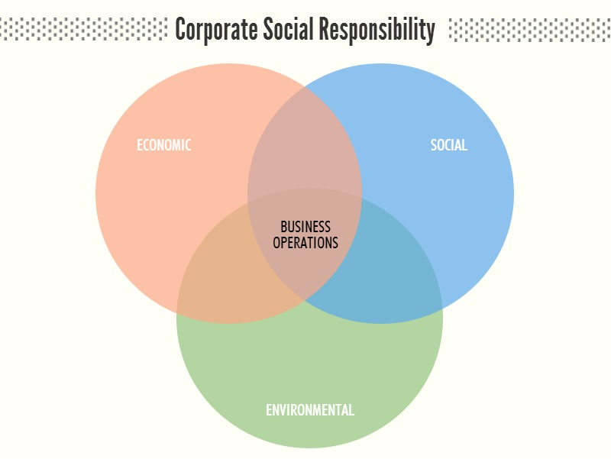

HOW TO INITIATE A GREEN OFFICE PROJECT

  - Know your office

In order to identify what needs to be done and improved within the office in terms of environmental friendliness, you need to know firstly the basis of your business.

Sample of issues you need to find out:
    - How big is your office?
    - Is there any environmentally policy been put in place?
    - Who is in charge of environmentally-related practices/policies, such as paper use, utility bills and procurement?
    - Are the staffs informed of any of changes in office environmental issues or policies?

  - Appoint a “Green Manager”

A “Green Manager” should be appointed within the office to assist in formulating, implementing and promoting green office policy and initiatives in your company and the Green Manager is responsible for the environmental performance of the office.

For medium-sized companies, you may appoint a “Green Ambassador” in each department to promote the green office initiatives. The Green Ambassadors will meet regularly (such as a month) to discuss and share ideas and challenges.

Promote office awareness and engagement

One of the main duties of the Green Manager/Green Ambassadors will be promoting office awareness and engagement which are crucial in a green office initiative. Without staff participation, no green office initiative will be successful.

Ways to raise office awareness and engagement:
    - Inform staff of the adoption of the environmental policy or green office initiative
    - Post the environmental policy and implementation progress report to the firm’s website/intranet for internal review
    - Use of awareness posters in common areas
    - Place switch off light signs near switches and door
    - Place energy and paper saving signs besides the desktop of every staff
    - Keep enthusiasm high by rewarding staff for energy saving actions (gift certificates, candy, etc. for winners)
    - Attain recognition from public environmental recognition awards/scheme (such as Environmental Labels from Environmental Campaign Committee under the Hong Kong Awards for Environmental Excellence scheme)

TIPS FOR GREEN OFFICE PROJECTS

  - 4-R principle

4-R principle is the basic principle in green management. The four “R” elements are:

    - Reduce
  - Reduce the consumption of products/materials

    - Reuse
  - Make full use of the products
  - Do not throw away the product if it is reusable

    - Recycle
  - Products can be recycled in two ways:

    - Give old products you don’t use anymore to other persons in need; or

    - Recycle broken but recyclable items so that they could be broken down into raw materials which can be used for manufacturing of other products.

    - Replace.
  - Use eco-friendly products instead of products which are not (e.g. use handkerchief instead of tissue paper)

You will find below tips and implementation steps for a green office incorporating the 4R principle.

  - Tips and implementation steps

Actions set out below have been categorised into three levels for their impact and difficulty.

Energy conservation

Level 1
  - Encourage staff to turn off lights in offices during lunch times or when out of the office
  - Remind staff to turn off all lights, air conditioning and computers when leaving the office
  - Set sleep mode default times for printers, photocopiers and computers
  - Ensure overhaul cleaning of fan coils at least once a year, for efficient use

Level 2
  - Install electricity monitors on equipment to monitor electricity usage and identify priorities for equipment replacement
    - Consider a 7-day Timer Switch for certain equipment (such as water filter, photocopiers and printers) to switch off equipment after office hours
  - Clear ventilation sources (which could be wasteful) and ensure that thermostats are appropriately set (set thermostat temperature to 25.5⁰C +/- 2⁰C)

Level 3
  - Install motion sensor lights in offices and low-use areas that will turn lights off if no movement is detected after a certain time period
  - Encourage building management to replace equipment with environmentally friendly and energy conserving products (such as replacing lighting with long-life bulbs, replacing broken toilets with toilets with water-saving features such as waterless flushing or dual flush, using environmentally-friendly cleaning products, installing motion detected lighting for common areas, etc)

Paper conservation

Level 1
  - Encourage staff to print/photocopy only when necessary
  - Encourage staff to disseminating documents/files electronically
  - Encourage staff to print/photocopy on double-sided paper
  - Encourage staff to print/photocopy multiple pages on one sheet if possible
  - Set doubled-sided printing as the default mode for printing for all network printers
  - Put a tray/box besides the printer for collection of used single-sided paper for reuse
  - Encourage staff to print draft documents on recycled single-sided paper
  - Load single-sided paper to fax machine

Level 2
  - Use e-fax to screen junk fax
  - Create note pads for internal use using single-sided papers

Recycling – reduction of waste

Level 1
  - Recycle used ink/toner cartridges
  - Investigate recycling of paper
    - Recycling for waste paper (including newspapers, paper towels, paper bags, packaging materials, cardboard, etc)
    - Recycling of shredded paper (requires confidential disposal)

Level 2
  - Introduce waste separation bins in the office for the Programme on Source Separation of Domestic Waste
    - Metals (includes aluminium cans, biscuit tins, clean food cans, pots, vacuum flasks)
    - Plastics (plastic bottles, plastic bags and packaging, clean plastic utensils, CDs)
    - Glass (glass bottles)
  - Designate a collection point for recyclable office products to be taken to the building recycle bins
  - Inform staff of items that may be recyclable, including the following office supplies and designate a staff member as the collection person for larger/special items that are not appropriate for the bins:
    - Rechargeable batteries
    - Electronic equipment
    - Nespresso capsules
    - Collect all spent toner/ink-jet cartridges for recycling
  - Donate old but still working office equipment to staff or charity in need
  - If there is a coffee machine in your office, use coffee grounds as air freshener in the office pantry or as an fridge deodorizer

Level 3
  - If your office building has not yet participated in the Programme on Source Separation of Commercial & Industrial Waste, encourage the building management to apply and to install recycling bins on each floor of the building/ in the lobby of the building
  - Compost food waste and coffee machine residue

Replace / Green procurement

Level 1
  - Replace office products with environmental friendly products, including recycled paper towels, recycled and non-chlorine bleached toilet paper, recycled paper for draft printing, and non-toxic cleaning chemicals
  - Select green suppliers for procurement
  - Consider purchasing recyclable laser printer toner cartridges and box files made of recycled paper
  - Consider purchasing replacement stationary such as recycled pencils and recycled letterhead/envelopes
  - Consider purchasing reusable cutlery and encourage staff to use reusable cutlery rather than disposable cutlery

Level 2
  - Lease office equipment instead of purchase
  - Replace fluorescent tubes in lighting with long-life tubes
  - Replace office products with environmentally-friendly products, including biodegradable garbage bags, eco-friendly dishwashing liquid, etc
  - Prioritise the purchase of new equipment with energy efficiency labelling (A++, Energystar) and furniture made of chip board

Level 3
  - Replace furnishings with no or low volatile organic compounds (VOCs) furniture (i.e. VOC discharge rate should not exceed 500 µg/m2 per hour), preferably containing recycled materials
  - Replace flooring materials with those holding a Greenguard, Floorscore or other certification

Beyond the workplace

  - Encourage “green practices” in every aspect of staff life
  - Encourage employees to give preference to products/ingredients grown or manufactured locally, vegetarian option, and to eat seafood on the “recommended” list of the WWF Seafood Guide and reject shark fin (http://www.wwf.org.hk/en/whatwedo/footprint/seafood/sci/species/)
  - Provide a location for staff to drop off reusable/recyclable materials (such as waste electrical and electronic equity (WEEE) and unwanted but still usable items, such as clothing)
  - Organise an employee half-day Saturday volunteer day with local environmental and charity communities dedicated to green issues, such as WWF and beach clean-up
  - Organise a green giving day to encourage employees to donate reusable items to local communities

Appendix I
List of Environmental Recognition Schemes in Hong Kong

- Hong Kong Awards for Environmental Excellence Scheme
  - Environmental labels
    - Participating organisations must define goals that will benefit the environment in a specific aspect and an Environmental Label will be granted to organisations that have successfully achieved a specific number of environmental goals. Applications accepted year-round
    - 4 types of labels:
      - Wastewi$e Label – minimum requirements for “class of good” label achieved if 3 new goals per year are met, “class of excellence” label achieved if 9 or more goals are met, label valid for 1 year & subject to renewal (http://www.hkaee.org.hk/english/category/enviro_label/wastewise_label/files/Wastewise_GB_eng_Apr2013.pdf)
      - Energywi$se Label – minimum requirements for “class of good” label achieved if 3 energy saving measures, “class of excellence” label achieved if 9 or more energy saving measures, label valid for 1 year & subject to renewal (http://www.hkaee.org.hk/english/category/enviro_label/energywise_label/files/Energywise_GB_eng_Apr2013.pdf), membership lasts as long as an organisation complies with the IAQwi$e Label requirements
      - IAQwi$e Label – sustainable indoor air quality (IAQ) practices that organisations could implement (http://www.hkaee.org.hk/english/category/enviro_label/iaqwise_label/files/IAQwise_GB_eng_Apr2013.pdf), membership lasts as long as an organisation complies with the IAQwi$e Label requirements
      - Productwi$e Label

  - Hong Kong Awards for Environmental Excellence Sectoral Award for SME
    - Applications once a year around April, check www.hkaee.org.hk to see whether application are open

- Carbon “Less” Certificates scheme encourages buildings and organisations to identify, and take measures to reduce their carbon footprints

- Caring Company - Caring for the Environment (Form 3C) (www.caringcompany.org.hk)

Appendix II
Do's and Don'ts of Paper Recycling

DO RECYCLE
 Office paper (e.g. letterhead, copy paper, business forms) and photocopies
 Colour paper
 Newspaper
 Index cards
 Computer printouts
 Envelopes and folders (remove adhesive flaps and plastic windows)
 Standard business cards
 Brochures, magazines, newsletters, unclassified reports, books and telephone directories (remove plastic covers, plastic-coated paper and ring binders)
 Corrugated cardboard and toilet roll cartridges
 Packaging paperboard (if not on plastic-coated paper)

DON’T RECYLE
 Thermal fax paper
 Adhesive removable notes
 Overhead transparencies
 Carbon paper
 Blueprint paper
 Cellophane
 Plastic- or wax-coated paper (e.g. milk cartons, candy wrappers, photocopies paper wrappers and drink boxes)
 Lunch boxes, paper cups or plates
 Napkins, tissue, paper towel
 Film
 Self-adhesive stickers or those with glue or tape
 Foil gift wraps
 Paper or cardboard that is contaminated with paint, chemicals, food, etc.

Source: https://www.wastereduction.gov.hk/en/dos-and-donts-paper-recycling.html

Appendix III
Useful Links

- Hong Kong Waste Reduction Website

- Labels for Recycling Bins (Landscape):
Paper ; Plastics ; Metals

- Labels for Recycling Bins (Portrait):
Paper ; Plastics ; Metals

- Labels for Materials Collecting Boxes (Landscape):
Single-sided Paper ; Double-side Printed Paper ; Reusable Envelope ; Used Rechargeable Batteries ; Used Ink / Toner Cartridges

- Posters
- Waste Reduction and Recycling Tips in Office ;
- Common Types of Office Waste Paper ;
- Common Types of Office Metals ;
- Common Types of Office Plastics ;
- Locations of Recycling Facilities in Office

- List of Local Suppliers for Waste Separation and Recycling Bins

- Chinese University of Hong Kong’s Green Purchasing Guidelines

- Environmental Protection Department

- Controls and Requirements of the VOC Regulation

- List of products with recommended green specifications

- List of Supplier or Manufacturers with Non-/Low-VOC Products for Sale

- Green Council Green Label Scheme

Hong Kong Awards for Environmental Excellence (HKAEE) scheme is one of the most prestigious and reputable environmental award schemes in Hong Kong. More details can be found in the HKAEE’s homepage.

